**Assignment 2**

**Name**: Ranjith M

**Roll No**: 7179KCTKCTKCTKCTKCTKCT19BIT030

**Team ID**: PNT2022TMID15253

**Project**: News Tracker

**CRUD OPERATION IN IBM DB2:**

1. **Create Table:**

CREATE TABLE assignment_user ( id INT NOT NULL PRIMARY KEY GENERATED ALWAYS AS

IDENTITY (START WITH 1 INCREMENT BY 1), email VARCHAR(50) NOT NULL UNIQUE, password_hash VARCHAR(64) NOT NULL, username VARCHAR(50) NOT NULL UNIQUE, rollno VARCHAR(15) NOT NULL UNIQUE

);

1. **Insert:**

INSERT INTO assignment_user (email, password_hash, username, rollno) VALUES ('suresh@gmail.com', 'suresh@12', 'suresh', '19BIT222');

1. **Read:**

SELECT * FROM assignment_user;

1. **Update:**

UPDATE assignment_user SET password_hash = 'suresh@14' WHERE rollno = '19BIT222';

1. **Delete:**

DELETE FROM assignment_user WHERE rollno = '19BIT222';

**Screenshot:**

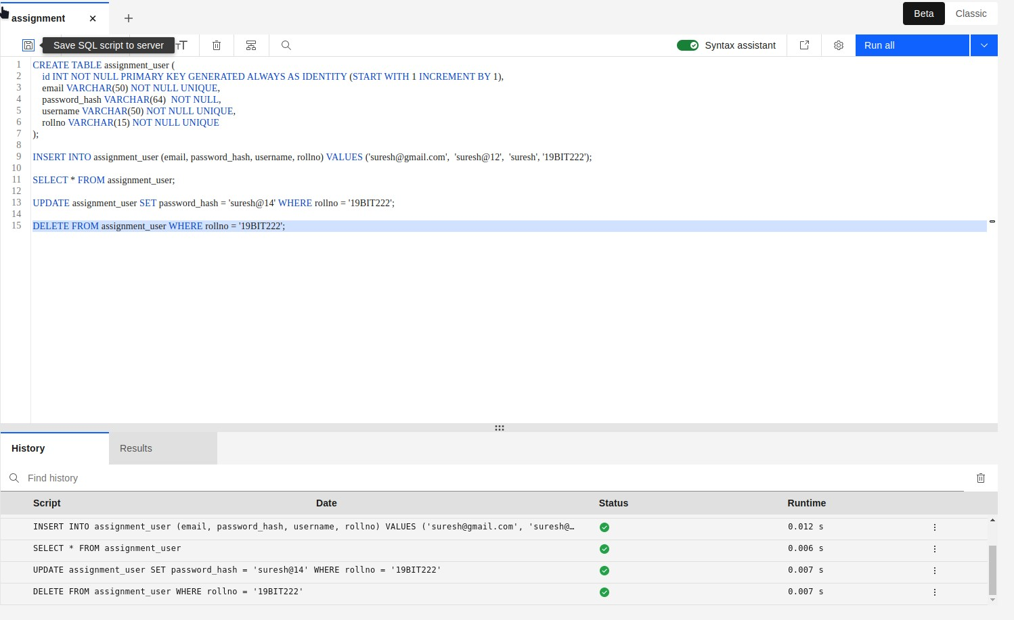

**Screenshot of flask app:**

